１.科研能力导向型硕士留学生课外活动体系构建与实施

1.1申报书

河北经贸大学国际教育学院来华留学生教学活动

申 报 书
项 目 名 称：科研能力导向型硕士留学生课外
活动体系构建与实施
项目主持人： 李 钢
所 在 学 院： 商学院
联 系 电 话： 13313035521
电 子 信 箱： ligangis@163.com
填 表 日 期： 2015年4月8日

国际教育学院制

填 表 说 明

1．填写此表时，不得减少栏目，内容应论述充分。填报内容较多时，请保持整页调整。
2．《申报书》宋体填写，一式四份，使用A4纸打印，左侧装订。
3．所有申请者签名处，不得用打印字和印刷体代替。
5. 项目组不超过4人（含课题负责人）。
一、简表
项目简况 | 项目名称 |  | 科研能力导向型硕士留学生课外活动体系构建与实施
项目简况 | 申请经费 |  | 元 |  | 拟开展项目时间 |  |  |  |  | 2015年5月  至6月
项  目  主  持  人 | 申请人姓名 |  | 李钢 | 性别 | 男 |  | 出生  年月 |  |  | 1971.1
项  目  主  持  人 | 申请人职务及  职称 |  | 副处、教授
项  目  主  持  人 | 教  学  工  作  简  历 | 时 间 | 课 程 名 称 |  |  | 授课  对象 |  | 学时 | 所 在 单 位
项  目  主  持  人 | 教  学  工  作  简  历 |  | 国际贸易理论与  政策 |  |  | 硕士 |  | 34 | 国际教育学院
项  目  主  持  人 | 教  学  工  作  简  历 |  | 国际商务英语 |  |  | 本科 |  | 51 | 国际教育学院
成  员  ︵不含负责人︶ | 姓名 | 出生  年月 | 专业技术职务及最终学历 |  |  |  |  | 项目中的分工
成  员  ︵不含负责人︶ | 成 健 | 1963 | 教授 |  |  |  |  | 项目实施督导
成  员  ︵不含负责人︶ | 张希颖 | 1972 | 教授 |  |  |  |  | 项目实施组织
成  员  ︵不含负责人︶ | 柳 巍 | 1989 | 硕士生 |  |  |  |  | 材料汇总、整理。
成  员  ︵不含负责人︶ | 唐洋洋 | 1986 | 硕士生 |  |  |  |  | 活动联系、安排。

二、立项背景与意义
1．项目描述
在我校留学生规模不断扩大、层次日益提高、国家级来华留学生全英语授课品牌课程建设日臻完善的背景下，迫切需要进一步积极探索全方位提高留学生培养质量的新路径和新方法。
本项目拟从提高硕士留学生科研能力的角度出发，以理论与实践相结合、课堂讲授与课外辅导相整合、独立分析与团队合作相协合、中外文化相融合为基本原则，重点策划和实施好以下三项既相对独立又有机结合的具体活动：
一、赴我省知名企业参观学习。通过与企业一线工作人员的深入沟通与交流，理论联系实际地发现真正有价值的研究命题。
二、组织专业学术沙龙。基于在实践中发现的研究命题，邀请相关领域的专家、学者共同研讨，以主题发言、调研报告、专业论文等形式形成具有实践应用和理论研究价值的科研成果。
三、举办中外文化交流体验活动。从建立更加融洽的师生关系、营造更为宽松的学术氛围，以及促进中外文化深层次融合的高度上，采取“茶与咖啡”主题聚会的形式，使中外师生在轻松、愉快的环境中迸发出思想的火花、智慧的评论。

2．本选题的意义和价值
全面提高硕士层次留学生培养质量，不仅是我校国际教育工作“上层次、提水平”的关键所在，而且是学校整体国际化办学事业发展战略的重中之重。本选题紧扣提高硕士留学生科研能力这一主线，重点围绕硕士留学生课外活动体系的构建与实施，通过三项既相对独立又有机联系的具体活动，不仅在现阶段形成有价值的科研成果，为进一步提高硕士留学生科研能力提供针对性强的指导意见；而且对全面提高硕士留学生的综合素质，促进我校国际教育的长期、可持续发展都具有一定的实践应用价值和理论研究意义。

三、项目实施方案
1．项目具体方案
2015年4月下旬：前期筹备，形成项目策划书。
2015年5月中旬：参观一家我省知名企业。
2015年5月下旬：组织专业学术沙龙。
2015年6月上旬：举办“茶与咖啡”主题聚会。
2015年6月中旬：项目实施情况总结、汇报。

2．项目拟达到的目标
（1）理论与实践相结合，使硕士留学生依据专业培养方向，在我省经济、社会发展实践中发现、分析和解决问题。
（2）课堂讲授与课外辅导相整合，通过体系化的系列课外活动安排使硕士留学生更好地掌握课堂讲授的知识。
（3）独立分析与团队合作相协和，既发挥硕士留学生独立分析经济问题的能力，又注重在课外活动中培养团队合作精神，联合攻关、共同提高科研能力。
（4）中外文化相融合，依托各自国家文化，引导硕士留学生运用独特的视角来观察和分析问题，既充分发挥各自国家文化优势，又紧密结合中国经济发展实际，切实提高硕士留学生科研能力。

3．拟解决的关键问题
（1）硕士留学生课堂理论学习和实践应用相互脱节的问题。
（2）硕士留学生科研能力有待提高的问题。
（3）硕士留学生培养水平提高路径单一的问题。

4．本项目的特色及创新性
（1）特色
在目前国际教育大多关注硕士留学生课堂教学效果的情况下，本项目从我校留学生培养和国际化办学事业长远发展的高度上，选取提高硕士留学生科研能力的独特视角，突出三项既相对独立又有机联系的特色活动，形成具有实践应用和理论研究价值的成果。
（2）创新点
为全面提高我校硕士留学生培养质量，促进国际教育工作水平进一步提高和国际化办学事业更好、更快发展探索新的路径和方法。
参观企业、学术沙龙、主题聚会等单独活动在留学生工作中比较常见，但以提供硕士留学生科研能力，将这些单独活动放在一个有机联系的硕士留学生课外活动体系中进行构建和实施的理论研究成果和实践应用实例却尚不多见。

四、经费预算
支出项目 | 金额（元） | 依 据 及 理 由
资料费
交通费
活动费
其 它
合 计
五、评审意见
（盖 章）
20 年 月 日

1.2学生作品

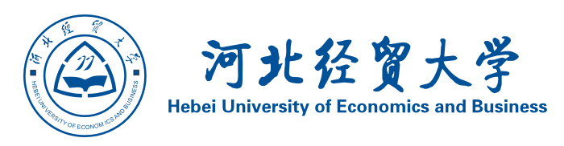

Junlebao Internationalization Strategy
By Gilberto Lam

A need or a desire, First of all it is important to know the reason why the company is looking to go international and if the company is prepared and has the resources to internationalize. A wasting of production capacity and a saturated domestic market could be a good reason to search for the internationalization.
What you leave for what you are looking for, According to the accessible data, Junlebao is number 4 in China, therefore without doing a deep research and supposing there are only 5 participants, we can figure out that its market share would be below 20% of the domestic market, so what it is important to analyze is the opportunity cost that Junlebao need to pay in order to go International, for logistics is almost sure the closer the easier.
An International brand needs an international name, The name of Junlebao is not friendly with foreign languages, let’s take the example of international Chinese companies like Asus, Haier, Lenovo, Foton, Midea, all of them successful Chinese companies. To change the name of the company is not only to be more friendly with foreign languages, it is also with the objective to avoid the customer to link the name with a Chinese company, unfortunately the issue about the baby powder milk in China was known worldwide, leaving a bad image about Chinese baby formula not only in China but also in other countries.
Old enemies becomes new friends, It seems that big part of the chinese consumers for milk powder prefer foreign brands rather than buy chinese brands and the market that the chinese companies are losing is getting bigger and bigger, so why not make an alliance with one foreign company, at the end what brings the confidence to the consumers is the name of the brand. Another option could be to search for an alliance with a foreign milk powder producer, either to have the exclusivity to distribute its product in China or either get the rights to manufacture the foreign brand inside China using Junlebao facilities.
The more the better, looking not only for national certifications but also for international certification would help the company to start gaining again the confidence of the consumers as well as be ready to export its product to other nations where having specific certifications is strictly compulsory.

Individual Assignment

A Concept Paper to Promote Junlebao
In International market.

Submitted By:
Bikash Thapa
HUEB
Introduction

Junlebao Dairy Co-Ltd is one of the leading dairy Company in china. Within the short time of period the company is able to conquer huge market space. There is no doubt that to achieve this success is not an easy work. After the successful market in China with the sale of 5 billion, we can think that it can be expanded to the international market also but the way is not easy. The company should think following things before the international marketing.

Inter-national Marketing Strategies.

- Market: Company should do a market research before entering to the market to take major decisions. The size of market, the customer, the location, the availability of materials, the distribution channel, the competitor and other elements that effects the market.

- Product: Company might have several different kinds of products; all the products cannot be introduced at the same time. So the product should be identified to the international market. It should be high end products and while identifying the product the company should think about the quality, taste and the flavor because different people have different taste. The society, the culture also affects the buying behavior of the customer. For the company at the initial phase it can introduce infant powder milk and natural milk without any flavor to the international market and gradually other flavored product according to the market taste.

- Quality: The product quality is the most important factor. Since the products are health related product, the quality should be maintained without the mixture of harmful chemicals. On the past years some dairy company has a bad reputation about the quality as a result still some dairy company suffers though the product has good quality. People are not trusting and assured about the quality. So the company should have some international quality certifications. So that people can be assured that the product is international standardized in quality.

- Collaboration or Joint venture: The Company can find other company in the host country for the expansion of the market. They can work together to promote the products in the international market.

- Foreign direct Investment: The Company has become very matured and experienced. The technology , human resources and the management skill is quite enough to establish a new company in the international market. If this could have been done it will be easier to compete with other competitor.

- Legal processes: Dairy products are health related products so there might have some strict legal provision for import and export and some legal standard of the product also.

These are the factors we should consider before entering to the international market. But in practice we should work a lot.

Bikash Thapa
HUEB

Internalization of Shijiazhuang Junlebao Dairy co. ltd

Ali Waheed
Student name:
20144131001 international education school
Student ID:

Degree program: Masters
Major: International business

Internalization of Shijiazhuang Junlebao Dairy co. ltd
After capturing a good local market share the company has potential to enter in global market.
Why company need to have an entry in global market?
There are certain benefits for Shijiazhuang Junlebao Dairy co. ltd to enter in global market.
- Resource acquisition
- Escaping from crises
- Enlargement of market
It’s a famous and useful saying that one should not have to put all eggs in one box; means don’t invest all resources in one place. By analyzing the strong competition in milk products producing companies in china, the Junlebao is facing many difficulties to maintain its position in market. So now it’s time for company to enhance its business to other countries for widens its market.
Strategies for internalization:
- Strong market research.
- Market segmentation with respect to products.
- In starting creating joint venture with other milk company to reduce risk.
- Cultural touch advertisements and promotions in host country.
- Investment in those countries which are non-agrarian because there will be more demand of dairy products.
The internationalization Process Mode: The UPPSALA MODEL
To explain the sequence of development, it was hypothesized by Johanson & Vahlne (1977, 1990) that firm would enter new markets associated with successively greater Psychic distance. Psychic distance was defined as the factors preventing or disturbing the flow of information between a firm and its markets, including factors such as Language, culture, etc. To explain the incremental nature of the process, Johanson & Vahlne (1977) further formulated a dynamic model, in which the outcome of one cycle of events is seen as providing the input for the following cycle. They established four stages of firm internationalization process. They posited that first are preoccupied with home market at initial stages and no regular export activities. After consolidated their presence in the home front, they extended their activities across border through exporting via independent representative or agents. The third stage involved firm committing their resource in the international market by establishing oversea sale subsidiary, while the final stage entailed establishment of foreign manufacturing/ production facilities. This preposition has been improved upon and integrated in their work in 1990 which is presented below. The basic structure of the model is provided by the distinction between state and change aspects of internationalization. The former include foreign market commitment (i.e., resource commitment) and knowledge about foreign markets and activities. The change aspects include the decisions to commit resources and engage in foreign activities.
The basic assumption is that market knowledge and market commitment affect both commitment decisions and the way current activities are performed which, in turn, affect market knowledge and commitment. (Andersen 1993.)

junlebao company
IFRAH AHMED ROBLEH

Student name:
201341310008, 爱妮，international school education

Student ID:

Acknowledgements

before I began I would like to thank all my dear professor to introduce one of the famous milk company in china and also all staff member to organize such amazing activities.
it's really help us to understand a all things as student study international trade .
brief introduction about junlebao
The Shijiazhuang Junlebao Dairy Co., Ltd. was established in 1995, after 18 years of development, now has nine production plants. Junlebao is the largest dairy enterprises in Hebei Province、National high-tech enterprise、national agricultural industrialization key enterprises. Junlebao trademark is well-known trademark of China. The products are sold in Hebei provice、Beijing、Tianjin and other13 provice and citys. The market share of Junlebao yogurt ranking forth in the whole country, the sales of Lactic acid bacteria drinks ranking second in the nationwide.
Junbao especially focusing on technology innovation. Annual R & D investment accounted for more than 5% of sales. Our technology center has completed more than 150 innovation projects. Pioneered the development of a series of health products such as dates yogurt and sea buckthorn yogurt that to create a precedent for the domestic health yogurt; Develop a domestic first functional activity lactic acid bacteria beverage – “Daily Bacteria” As a State-level and provincial-level agricultural industrialization key leading enterprise, Junlebao is not only pursuing self-development but also focus on upstream and downstream industry development such as dairy farming, forage grass and fodder, transportation, packaging and decoration and so on which to make Agro-pastoral industry forming a virtuous circle, establish a long-term, stable and win-win partnership with the local famers, more than 100000 famers get benefits, resulting in significant economic and social benefits.
In the next five years, Junlebao will increase the proportion of high-end products, and profitability. Strengthen brand building, create a nutrition and health professional dairy brand image. Strengthen the the milk management to ensure the quality and safety of the raw milk, to maintain the national low-temperature fermentation milk industry leader, to become “China nutrition and health dairy leader”.
For this individual assignment, we are asked to talk about how internationalize a company as junlebao. Thus, to answer this question, we will focus on what is internationalization and what is the process, and we will take example like Tesco’s Internationalization.

internationalization

Internationalisation is a process of integration in international activities and an answer to the opportunities and challenges of globalisation. Internationalisation must be the main part of a long-term strategy of companies, which particularly applies to small and medium-sized enterprises.
The Process of Internationalizing
The decision to “go global” is dynamic, and it is not susceptible to a “one size fits all” approach. Nevertheless, companies tend to follow certain patterns as they move beyond their own borders, and Exhibit presents a reliable model of the typical process of internationalization. It illustrates the interaction between and among components of an organization and shows how a company typically grows into becoming a full participant in the global arena. As a firm expands its activities into the international marketplace, its managers are usually faced with increasing risk and decreasing profits. As with any new venture or initiative, there is a learning curve that every company follows, even with the best planning. Expertise is developed gradually, and during that process there is a high degree of uncertainty. At the same time, the need for upfront investment saps short-term profits. Over the longer term, these factors.
exhibit 1 .A Model of the Internationalization Process
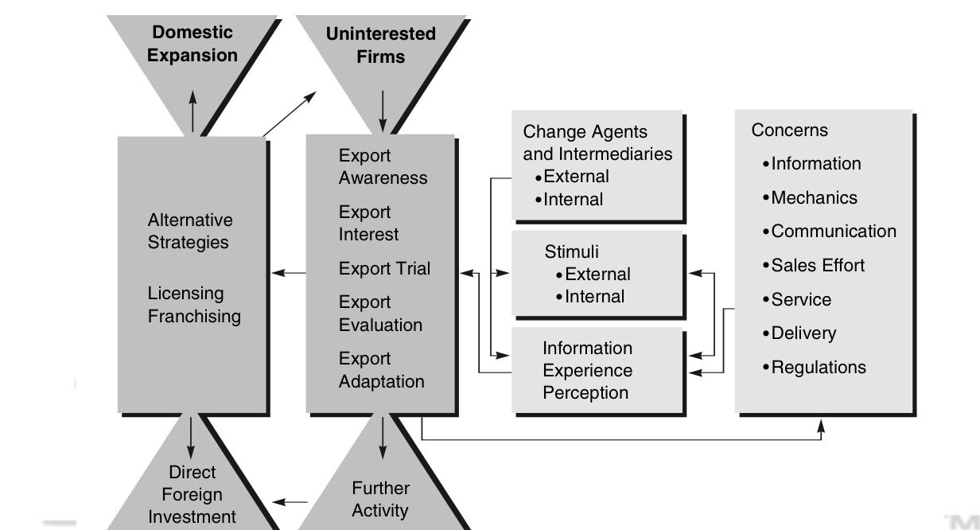
stabilize as the firm becomes more knowledgeable and experienced, but for the short term the ride can become very difficult. Successful performance can be achieved in three ways: effectiveness, efficiency, and competitive strength. Effectiveness is characterized by acquisition of market share abroad and by increased sales. Efficiency is manifest by rising profitability. Competitive strength is re- flected by increased market share.

Why do firms internationalise?
At the most basic level, firms’ motivations to carry out FDI can be summarized by descriptive lists where the firms’ reasons are certain to fall under at least one of the following categories
- Resource seeking
- Market seeking,
- Efficiency seeking,
- Strategic asset seeking
These can also be split up in greater detail, and divided into ‘push’ (also ‘proaction’) and ‘pull’ (also ‘reaction’) factors as junlebao.

Ownership advantages are company assets used to obtain market power linking to Hymen's firm specific advantages (FSA) and the core competences or resource-based school of corporate strategy. These advantages can be asset based or transaction-based. Transaction-based advantages come about because of the way things are done. ownership advantages are the firm’s belief to be fit, in terms of skill or assets or both, to survive and compete in the foreign market.
Location advantages describe how attractive a foreign country is to a retailer, and these factors are usually grouped as push or pull factors . While push factors make the home market less rewarding , pull factors make a foreign market attractive. The factors to measure the investment incentive have been added to the framework.
Cultural proximity and Geographic proximity facilitate entering a new market, because it reduces uncertainty. For example most companies seem to first expand into similar markets. After moving into Mexico, Wal-Mart’s second expansion was into Canada in 1994, and Tesco’s first expansion was into central Europe, then Ireland (after a failed attempt in 1979) and then into East Asia.
Market Size: Saturation of the home market is a major motive for expansion into other markets, and it is not by chance that European companies (e.g. Carrefour, Ahold, M&S, Tesco, Sainsbury’s) internationalized earlier than American companies (so far only Wal-Mart has built up a significant overseas store network, which have much more scope for expansion in the US market and where it remains easier for longer to grow by building another store in an unexploited region in the home market.
Competitors’ moves: According to Wrigley (2000), Carrefour, one of the first internationalization movers, was able to achieve exceptionally high returns “on invested capital in the 25 to 30 per cent range” in emerging markets (Brazil, Poland) where it didn’t face competition from western-style large-store retailers. The opportunities in the emerging markets in the form of prime locations, especially larger ones, are limited, or a retailer could have built up scale and trust which would be more difficult to overcome by late-movers. Hence, Carrefour enjoyed a first mover advantage and catching the growing middle class effect. So once competitors are acting, only a quick response could prevent them from establishing themselves rapidly. Walmart’s acquisition of ASDA in 1999 could have accelerated Tesco’s international expansion because Tesco was expecting competition to intensify.
Low cost land and labour: The decision of selecting a market may depend on the availability of suitable acquisition targets and the condition of potential sellers as it does on the attractiveness of the market . For the retail sector the availability of skilled, culturally aware management might also be a factor. The Asian crisis of 1997 seemed to rather facilitated the expansion, and offer more opportunities to acquire assets cheaply.
If Internalization advantages outweigh the benefits of using the market the firm will use some FDI method over contracting. The greater the company’s ownership assets, the more important it is to protect these assets by maintaining control over company secrets. orders the entry modes according to the level of cost and control (internalization) which will be discussed in more detail below.

How to go international?
Picking up the thread at the internalization point of the paradigm, the business which passed all conditions of the eclectic paradigm will already have rejected the options of expansion via trade and contracts because they require more control over their competitive advantage.

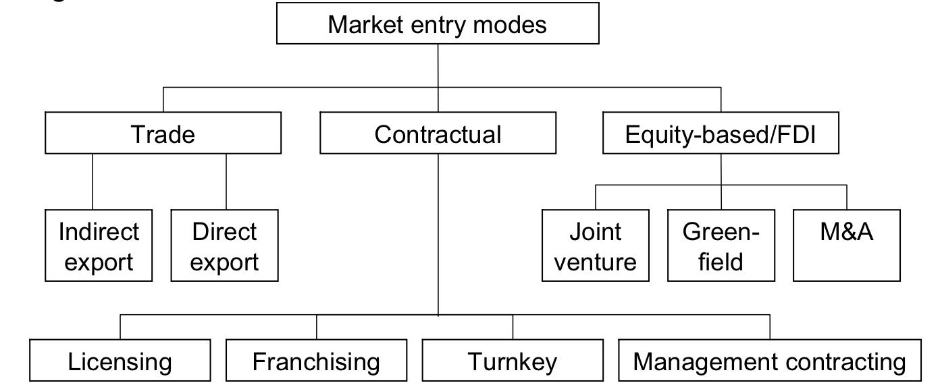

Tesco’s Internationalization
Tesco has varied its entry method in each region. In newly created markets in central Europe Tesco acquired stores from competitors (Kmart) and the state at low cost. In East Asia it follows a partnership approach whereby it enters new markets through joint ventures with local retailers. This gives it initial scale and access to knowledge of local political and institutional conditions, as well as a ‘local face’. Such partnerships are often followed by the acquisition of larger stakes (Wrigley, 2005). Initial investments were rather small to minimize the risk (Palmer, 2005). Tesco has entered its first and culturally most proximate markets with a fairly unchanged retail model (‘global’) but adopted a local strategy when it entered the east Asian markets (‘multinational’). In Thailand, where transportation is expensive but labor is relatively cheap, Tesco adapted its logistics to this situation. It has developed small format skill, which also circumvent trading hours regulations. It has developed a low cost ‘value’ format for up-country expansion – a hypermarket format surrounded by leased space for local fresh fruit and vegetable vendors – which provides a vehicle for entry into neighboring economics (Wrigley, 2005). Tesco’s first ever hypermarket was built in Asia, not in the UK. Tesco’s expansion into the US is considered to take place under a different brand name. And while Palmer describes the 1990s as “one of the most intense periods of retail merger and acquisition driven internationalization” Tesco took its time and entered markets sequentially rather than simultaneously. Several competitors had to withdraw from markets (Carrefour: Slovakia/Czechoslovakia, Wal-Mart: Germany, Kmart: Czecheslovakia/Singapore), and even though not all of Tesco’s market entries were successful (Tesco had to divest its Chateau acquisition in France, 1990, Taiwan stor swap with Carrefour, 2005), today it can show a handful of market-share leaderships in significant markets. Using a multinational strategy means that expansion will be slower than that of global retailers, but the advantage of this method is a greater learning effect each country mastered gives the retailer a broader knowledge base. On each occasion Tesco’s strategy matched the conditions of the environment. Tesco stands for an ‘intelligently federal’ method of international expansion (and this includes several other European retailers, such as Carrefour and Aldi) while (the only) US retailer Wal-Mart adopted an ‘aggressively industrial’ modele.
Conclusion
The text so far has shown in which situations and how retailers will go international. But the broad frameworks did not capture qualitative details such as internal firm specific factors and external or home market specific issues, or only vaguely. For example, Coe (2003) refers to Wrigley (2000) as the “most convincing account” of retailer internationalisation. Wrigley describes how overseas expansion was not simply a defensive reaction to overdependence on the home market, but was also fuelled by a need to sustain earnings growth (and therefore equity valuations) by using their free cash flow to secure revenue growth. Diversification into non-food was a second pillar of this attempt. Pressure from financial institutions and shareholders was a significant factor (cf Palmer, 2005). What are the drawbacks? Just like Tesco’s expansion into non-food, international expansion diverts management attention away from the still competitive UK retail market. There are more balls to juggle. And international expansion carries significant risk, due to Tesco’s relatively weak position against its much larger and more experienced international peers: • Acquisition outside the UK may prove highly dilutive • The size of possible acquisitions are effectively reduced • A merger with a large European retailer would leave Tesco as the junior partner and • Tesco is more vulnerable to an aggressive bid In addition to these risks, Tesco has to keeps its secrets internal (loyalty card, online) to maintain its ownership advantages. At the same time Tesco must make sure to maintain their customer focused culture despite international acquisitions and to find the right mix between global operations that allow standardization and multinational (local) adaptation that are required in each market - globalize where possible, localize where necessary. The literature does not give a single view on internationalization, and it is clear that the reasons for international expansion, in their weighting at the very least, will differ for each company, as will necessarily their optimal entry modes. To give a systematic account of the motives of internationalization that can be applied to every firm, broad and universal categories as used by the eclectic paradigm are necessary. As pointed out, this might lead to exogenous factors such as the capital markets, or internal causes (firm structure, organizational culture or politics) not being captured by the model. Hence careful qualitative research (e.g. interviews) is required to in find those reasons.

1.3项目总结

“科研能力导向型留学生课外活动体系构建与实施”
2015年来华留学生教学活动结项总结

一、 项目基本情况
在我校留学生规模不断扩大、层次日益提高的背景下，本项目从提高留学生科研能力的角度出发，以理论与实践相结合、课堂讲授与课外辅导相整合为基本原则，重点策划和实施了参观企业、学术沙龙、主题聚会等三项既相对独立又有机结合的具体活动。
项目主持人李钢，立项时间2015年4月，项目实施时间2015年6月。

二、 项目实施过程
1. 参观我省知名企业
在前期充分准备的基础上，2015年6月9日带领留学生参观我省著名企业石家庄君乐宝乳业有限公司。通过实地参观考察和与企业一线工作人员的深入沟通与交流，引导学生结合本专业所学知识，理论联系实际地发现真正有价值的研究命题。
2. 组织专业学术沙龙
基于在实践中发现的研究命题，邀请相关领域的专家、学者共同研讨，在中外文化深层次融合的高度上，深化对专业问题的探讨和研究。
3. 举办“茶与咖啡”主题聚会
围绕企业参观、学术沙龙中探讨的问题，采取主题聚会的形式使中外师生在轻松、愉快的环境中迸发出思想的火花、智慧的评论。
4. 项目总结与成果发表
对学生提交的论文进行修改、完善，并对整个项目活动进行总结，形成具有实践应用和理论研究价值的科研成果，通过项目总结报告会、企业建议书、专业刊物投稿等多种方式，充分发挥项目活动的理论研究和社会应用价值。
三、 项目成果和意义
1. 以提高留学生科研能力为切入点，让同学们依据专业培养方向，在我省经济、社会发展实践中发现、分析和解决问题。
2. 通过体系化的系列课外活动安排使留学生更好地掌握课堂讲授的知识，不仅做到课堂讲授与课外辅导相整合，而且注重在课外活动中培养团队合作精神，联合攻关、共同提高科研能力。
3. 依托留学生各自的国家文化，引导同学们运用独特的视角来观察和分析专业问题，既充分发挥各自国家文化优势，又紧密结合中国经济发展实际，以我省的知名企业为实例，不仅在现阶段形成有价值的科研成果，而且对全面提高留学生的综合素质具有重要意义。

